**Objective**

* Identify and establish design Outputs and verification methods
* What subsystems and components go into your medical device?
* How are these components put together?
* Define materials, components, sub-assemblies, Engineering Drawings, specifications, manufacturing instructions
* Document how to assemble this product

**Resources:**

[MIT Open Source Design Toolbox](https://drive.google.com/open?id=1yQP-8z1lwNbFmEWAXvjOD5f-P2mVK4Fl)

[Mechanical](https://drive.google.com/open?id=10tynfGtlCd191f5StNU1kuTGo9EVSMcX)

[Electrical and Control](https://drive.google.com/open?id=1jqn9Ix_PmpIytmHLSGV70KiE_1Nvi6AR)

Clinical Requirements From [Product Specification](https://drive.google.com/open?id=104SlG0-raS4feIjTKrI_sFwBLwEB8Xz_)

[Jam Vent Design Document](https://docs.google.com/document/d/1iK6iSKT1I55DGZn7AiBnYsVvJPS6xgh1VcrWnxypKIk/edit?usp=sharing) - Use as reference and sample

[Splitter Design](https://drive.google.com/file/d/1grHS_Hvk6ieL0i-mhWVSgwfzK9hLmkfg/view?usp=sharing)

**Mechanical**

**Power Calculations**

This section will discuss the estimated maximum power required by a motor used to compress an Ambu bag. Different designs, with other actuation methods, will change motor specifications, but the power should stay approximately the same.

1. Independent of the mechanical design of the gripper, the required power output can be computed from the worst-case values of the following variables:
   1. Maximum pressure at airway: *P*airway,max = 40 cm H2O (pop off cracking pressure)
   2. Maximum respiration rate, the rate of breathing cycles every minute: *RR*max = 40 bpm
   3. Minimum inhale/exhale ratio (The proportion of each breathing cycle that is spent breathing in compared to breathing out.) of 1:4: IEratio, min = 4
   4. Maximum volume output: *V*max = 800 cm3
2. The volumetric flow rate needed in the worst-case (peak) scenario is, *Q*airway = *V*max / *t*inhale = 0.0027 m3/s
3. The power output (in the form of pressurized volume flow in the airway) is, *Power*airway = *P*airway,max *Q*airway = 10.46 W
4. Estimate that 50% is converted to pressurized volume flow. Taking this efficiency into account, the power required at the gripper is: *Power*gripper = 2 *Power*airway = 20.92 W
5. The actual power needed from the motor will be higher, how much higher depends on the mechanical and electrical designs. Assuming half the power output of the motor is lost to mechanical and electrical inefficiencies (gears, thermal dissipation, etc.), the power output required from the motor is given by:

*Power*motor = 2 *Power*gripper = 41.84 W

1. The minimum motor power is approximately 70 W. Therefore, a power supply at 12 V should be specified with a minimum of a 5.8 (~6 A) supply.
2. The torque required of the motor will be a function of whether the arms are driven directly or with a driving pinion. It is essential to consult your motor curves and apply a safety factor.

**Motor Selection**

**Plumbing**

Describes critical design requirements of the patient breathing circuit

1. self-inflating manual resuscitators are directly connected to the patient’s endotracheal tube adapter
2. Manual resuscitators have a “patient valve” that directs oxygen/air gas mixture into the patient and shunts the exhaled gas out to the environment
3. Integrated into the end bag valve bag (BVM) are a number of critical features:
   1. Oxygen connection and reservoir
   2. Pop-off valve for safety
   3. One-way valve that guides air to the patient
   4. Exhalation valve ( this stays closed while there is any pressure on the bag)
   5. PEEP valve that is installed post the exhalation valve and maintains backpressure
   6. Sensing port for manometer connection
4. Some considerations regarding how the patient should be connected to a manual resuscitator-based ventilator include:
   1. The ventilator must be placed as close to the patient as possible.
   2. Bag should be secured to the ventilator to prevent an awake patient from pulling on it or otherwise disengaging the bag from the mechanism. This is a fault condition that should be detected by pressure sensing.
   3. Care must be taken to prevent rebreathing of CO2 due to long hoses. A fundamental challenge is the location of the one way and expiratory valves, which are typically directly integrated into the bag.
5. When a manual resuscitator is placed into an MIT E-Vent, or similar design, the system cannot be placed right up against the patient’s head.
6. Patients need to be turned intermittently for routine care and patients can thrash and move in their beds. Even when patients are paralyzed, the paralytic may wear off at times and we must consider how to keep the patient safe from inadvertent breathing circuit disconnection or extubation.
7. A safe method to extend the “reach” and flexibility of the manual resuscitator to a patient lying on a hospital bed is needed.
8. Standard ventilator circuits have two limbs, one for inspiration and one for expiration, so that gases can be recaptured by the ventilator. (Dual Limb Circuit is not suitable for E-Vent)
9. Single limb ventilator circuits with a patient valve located distally already exist on the market, but are not necessarily optimized for use with a manual resuscitator.

* Pop-off valve and must install filter before peep exhaust

1. Recommended plumbing contains: pop-off valve, tracheotomy tube, endotracheal tube, PEEP valve, HEPA filter, sensing port connection, optimal elbow.
2. Notes based on products available on the market:
   1. No bag makers supply extension hoses with the appropriate fittings.
   2. Bags designed for reuse, i.e. autoclavable, are the only bags that can potentially survive under repeated use.
   3. Some Ambu bags do not have detachable heads, but they do incorporate pop-off and easily attached PEEP valves in their designs. They can only be used if extended with a separate head and extension tube. Ambu Mark 5 and Silicon Oval heads are detachable and may be available as parts. They have easily combined manometers and PEEP valves.
   4. Laerdal bags do have detachable heads, however in the adult sizes these heads do NOT come with pop-off valves; these are available in the Pediatric model. The pediatric model head will probably fit the adult bag.
   5. When a long tube is used, without a dual limb circuit and one way valving to address the dead space issue, this may affect the volume delivered to the patient; it may be necessary to increase the inspired volume.
   6. Addition of the HEPA filter will cause a pressure drop and may affect PEEP settings.
   7. Tightness of all connections is important.
3. Two versions of single limb circuits are shown below:
   1. The first uses readily available components and two printed adaptors to make them fit together, with the HEPA filter placed between the exhalation port and the PEEP.
   2. The second uses a single limb breathing circuit, with most of the necessary features integrated, and a HEPA filter added inline between the porcine and the breathing circuit. This is a better position as it filters air heading both in and out of the patient, including any air that escapes from the pop-off valve. It may also help to moisten air inbound to the patient.
4. All Ambu valve assemblies have a conical taper from injection molding that allows for a reliable adapter connector to be quickly fabricated.
5. A hose can now be used to connect this valve to an intact manual resuscitator
6. Adapt factory valve assembly to standard ISO 22mm/15mm Tube Fitting and SPUR II adaptation 25.75 mm to 26mm taper solid connection w/o adhesive.
7. Pressure sensor can be fitted directly to M-port or air extension tube to ABVM
8. Patient breathing system connections: the ventilator must present 22mm outside diameter (OD) ‘male’ standard connectors to ISO 5356-1:2015 on both outlet and inlet ports for connection to user supplied 22mm ‘female’ connectors on the breathing system. These must be rigid and robust (not plastic) and separated by a minimum of 10 cm between centres to accommodate filter HMEs.

**Bag Sizing**

1. The bag should be centered laterally and vertically between the grippers
2. For practical purposes, spacing the bag mounts 21 cm apart should fit most bags, but the mounts must have vertical adjustability.
3. Ambu bag options:
   1. **Ambu SPUR II** provides users with exceptional tactile and visual feedback during resuscitation. The bag is highly responsive, featuring minimal mechanical resistance. Moreover, the characteristic design provides the optimum in respect to stroke volume and recoil.

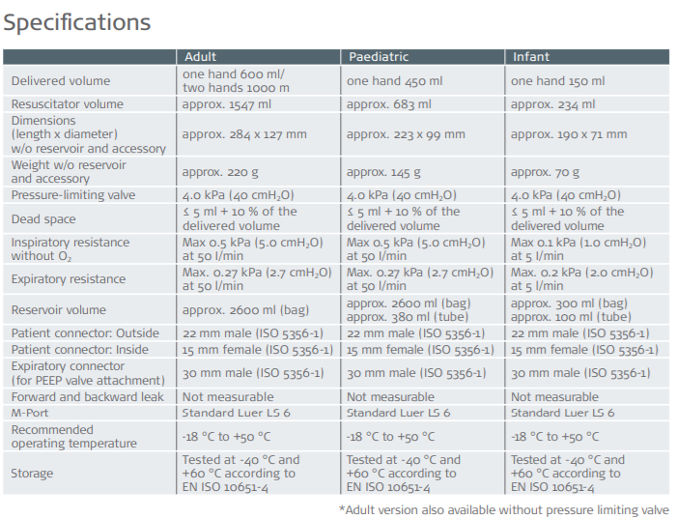

* 1. CareFusion Self-Inflating Resuscitation Bag is reliable and affordable. It features a low-profile, textured bag, manometer port, double-swivel elbow, removable accumulator and 10 feet U/Connect-It fitting for easy connection to an oxygen source. It is disposable and Latex-Free.
  2. **Laerdal The Bag** - is large. Care must be taken to not pinch the bag when compressed and, as seen here, the bag lifts up and out in current configuration. This is not a good fit and longer arms are needed.

-This product is in compliance with the essential requirements of Council Directive 93/42/EEC as amended by Council Directive 2007/47/EC.

### Technical:

* Material: PVC, PC, SI, Polypropylene
* 35cm Pop Off Available for Child & Infant models
* Does not contain latex
* Patient Valve Dead Space: 6.8 ml
* Inspiratory Resistance: 1.5 cmH2O @ 50 LPM
* Expiratory Resistance: 1.8 cmH2O @ 50 LPM
* Storage Environmental Temperature Limits: -40°C to +60°C
* Operating Environmental Temperature Limits: -18°C to +50°C
  1. The Portex- latex free

1. The table below gives dimensions at the contact points and the center of the bag. We place the bag with the bottom towards the motor and head, with patient valving, overhanging.

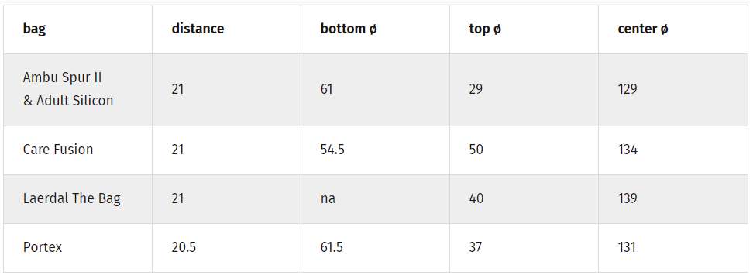

**Controls & Electrical**

Electrical Hardware

Controls

Circuits Diagram

Pressure Measuring

List of Alarms